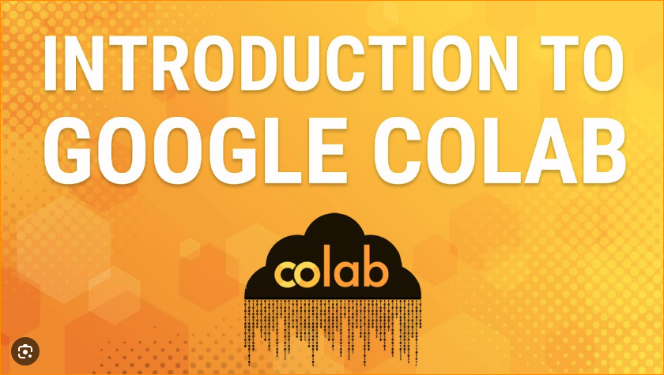

1. What are the google develop frameworks for AI?

* TensorFlow:

Description: TensorFlow is an open-source machine learning library that is widely used for various AI applications, including deep learning and neural networks.

Key Features: Flexibility, scalability, and support for both research and production.

* PyTorch:

Note: While PyTorch is not developed by Google (it's primarily developed by Facebook's AI Research lab), it's worth mentioning as it's widely used in the AI community. Google's researchers and engineers often contribute to the PyTorch ecosystem.

* Cloud AI Platform:

Description: Google Cloud AI Platform is a cloud-based service that provides tools and services for building, training, and deploying machine learning models on Google Cloud.

1. Why Google colabs?

Google Colab, short for Colaboratory, is a free cloud service provided by Google that allows users to write and execute Python code in a collaborative environment. Here are some reasons why Google Colab is popular:

1. Free Access to GPU and TPU:

One of the key advantages of using Google Colab is that it provides free access to Graphics Processing Units (GPUs) and Tensor Processing Units (TPUs). This is particularly beneficial for machine learning tasks that involve training deep learning models, as these hardware accelerators can significantly speed up the training process.

1. Cloud-Based and Collaborative:

Google Colab is entirely cloud-based, which means users don't need to worry about hardware specifications or setups. It allows for collaborative work in real-time, making it easy for multiple users to work on the same notebook simultaneously. This is especially useful for team projects, teaching, or collaborative research.

1. Pre-installed Libraries:

Colab comes with many popular Python libraries pre-installed, including TensorFlow, PyTorch, and scikit-learn. This reduces the setup time and allows users to start working on their projects more quickly.

1. Integration with Google Drive:

Colab is integrated with Google Drive, allowing users to save and share their work easily. Notebooks are saved directly to Google Drive, and users can open and save notebooks directly from the Google Drive interface.

1. Easy Sharing and Publishing:

Colab notebooks can be easily shared just like any other Google Drive document. This makes it convenient for collaboration and for sharing code and analyses with others. Notebooks can also be published to the web, making it accessible to a broader audience.

1. Access to Google Services:

Colab allows users to access various Google services directly from the notebook, such as Google Sheets, Google Docs, and BigQuery. This integration enhances the capabilities of Colab for data analysis and manipulation.

1. Educational Use:

Google Colab is widely used in educational settings due to its ease of use, accessibility, and the fact that it requires minimal setup. It is a popular platform for teaching and learning Python, data science, and machine learning.

In Site - Colab, or "Colaboratory", allows you to write and execute Python in your browser, with

* Zero configuration required- no need any packages
* Access to GPUs or TPU free of charge – Performance highest(GPU use to train AI model Faster, GPU can process multiple computers simultaneously, Memory band high therefore can handle large amount of data. )
* Easy sharing

1. Add text –

In here add your texts and press Shift + Enter

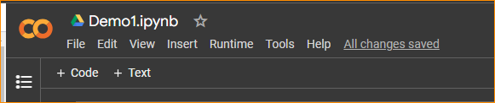

1. Write a Code – Click code and run press button

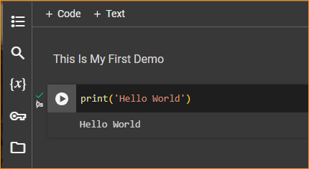

1. Check Performance –

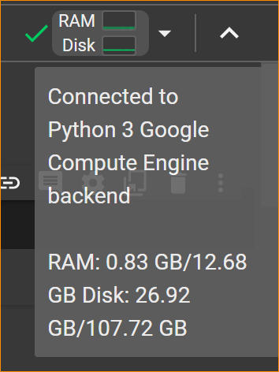

1. Connect to GPU-

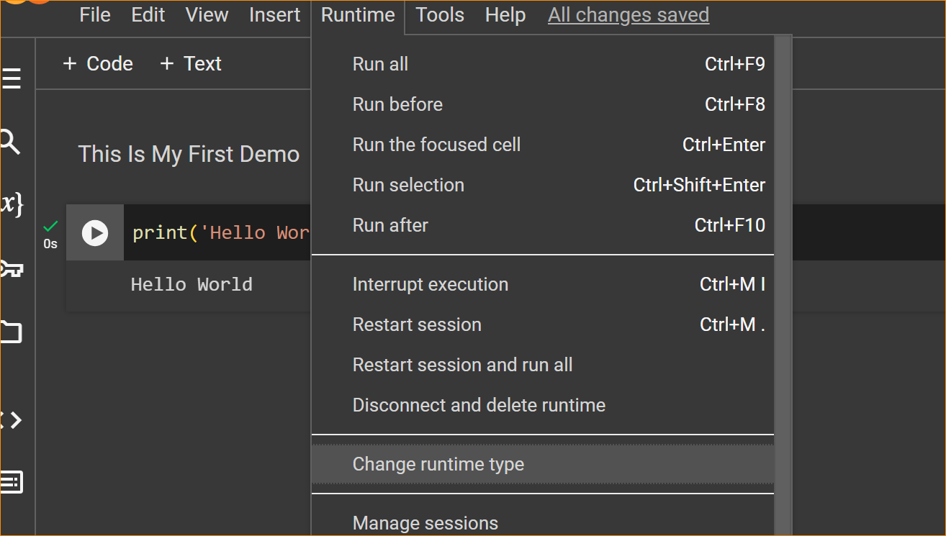

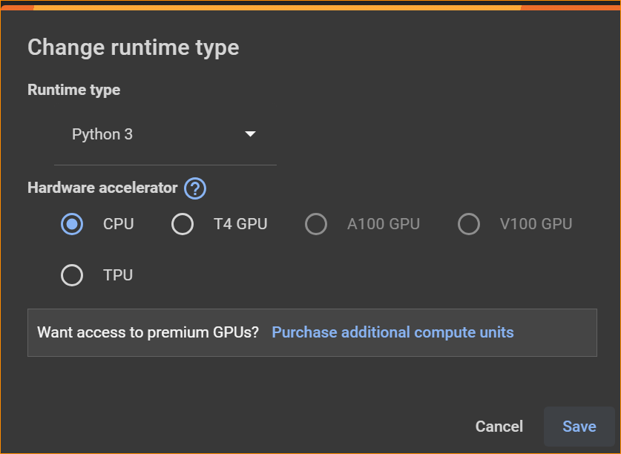

If you are not connect to the GPU or TPU The Default TensorFlow code shown error like this,

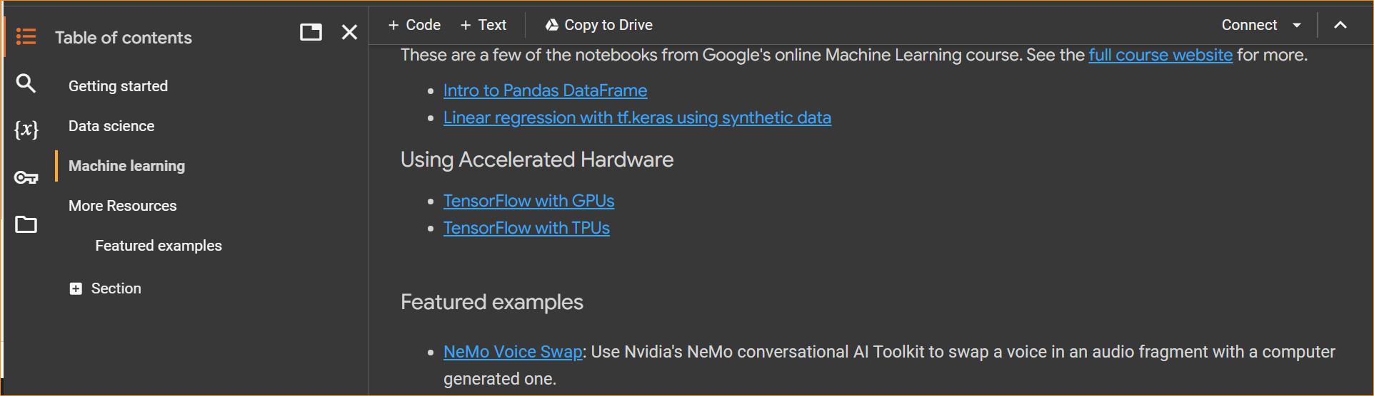

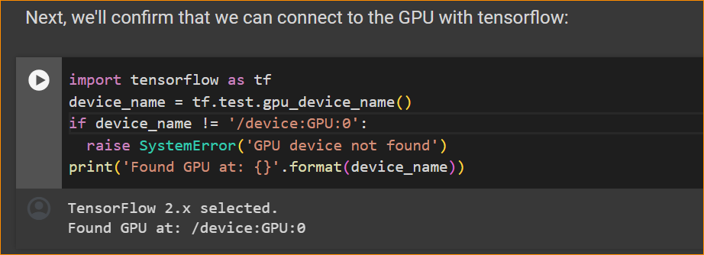

If we not connected CPU –

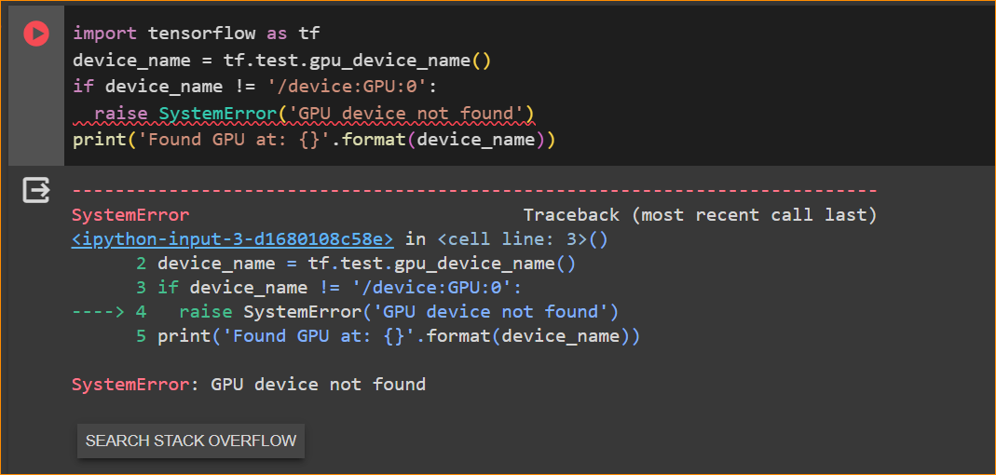

1. Connect With google Drive –

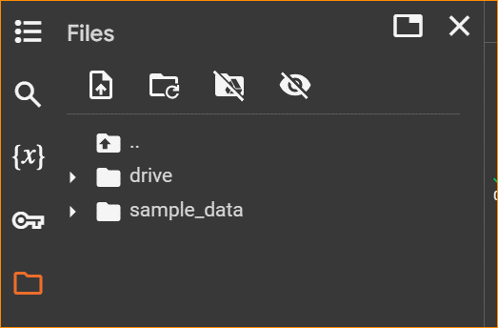

1. Assess to the data set of the google Drive-

* Check if we connected to drive- Print ‘pwd’

What is the pwd mean?

When you run this cell, it will execute the "pwd" command, and the output will show the current working directory within the Colab environment. This can be handy when you want to navigate the file system or confirm the location where your Colab notebooks are stored.

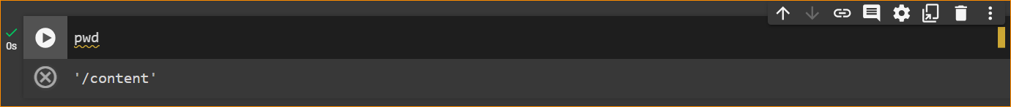

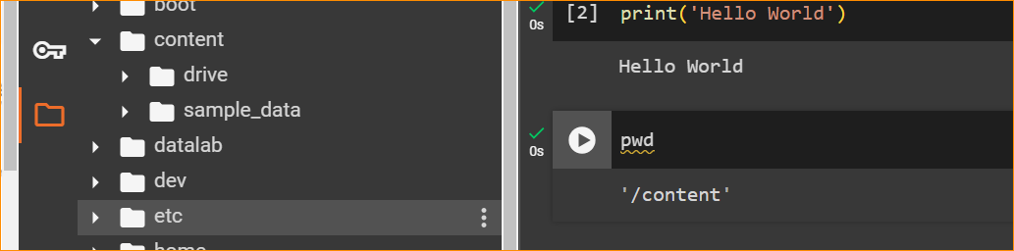

Now steps-

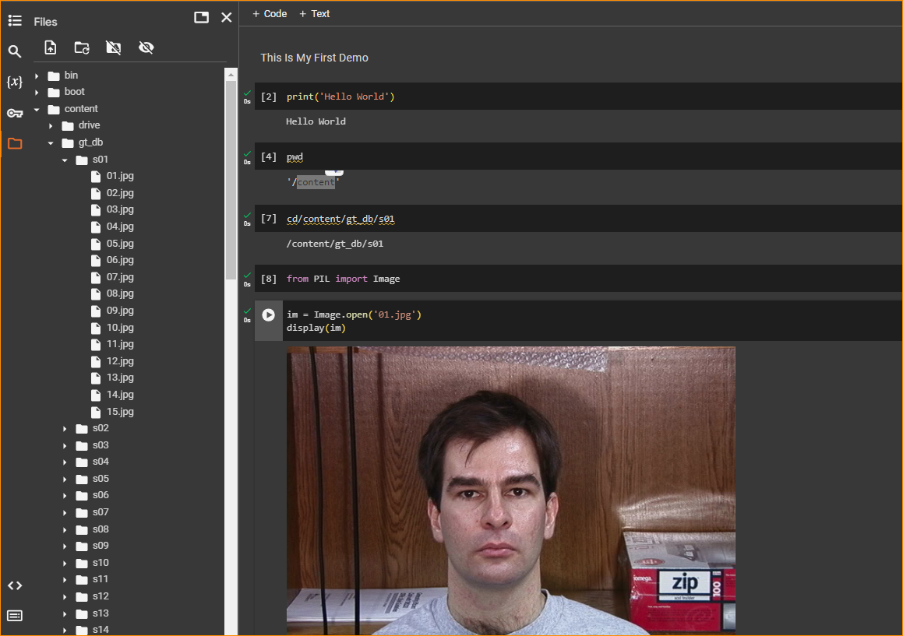

PIL library –

1. Pillow library

Pillow is the friendly PIL fork by Jeffrey A. Clark (Alex) and contributors. PIL is the Python Imaging Library by Fredrik Lundh and contributors.

Pillow for enterprise is available via the Tidelift Subscription.

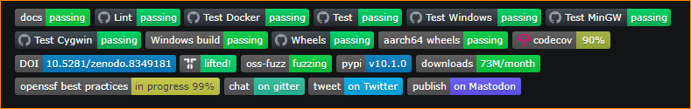

Image module - <https://pillow.readthedocs.io/en/stable/reference/Image.html>

Pillow is a modern version of PIL that continues to be actively developed and includes additional features and bug fixes. It is a popular library for working with images in Python and is widely used in various applications, including image processing, computer vision, and web development.

Once installed, you can use Pillow in your Python scripts or notebooks for image-related tasks. If you have specific image processing needs, you can refer to the Pillow documentation for details on how to use its features: Pillow Documentation.

1. How to Assess the GitHub dataset –

<https://github.com/COVID19-Malta/COVID19-Data/blob/master/COVID-19%20Malta%20-%20Aggregate%20Data%20Set.csv>

* I want to assess to this data set using colab-

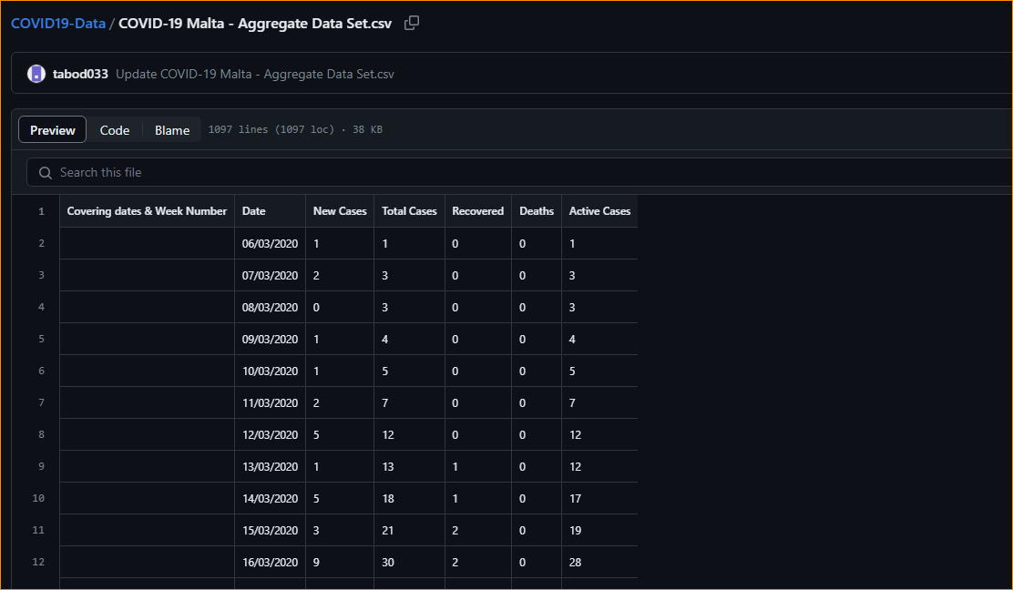

Convert your dataset in to raw format-

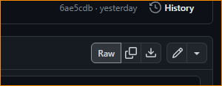

And using this link can assess to dataset from colab- <https://raw.githubusercontent.com/COVID19-Malta/COVID19-Data/master/COVID-19%20Malta%20-%20Aggregate%20Data%20Set.csv>

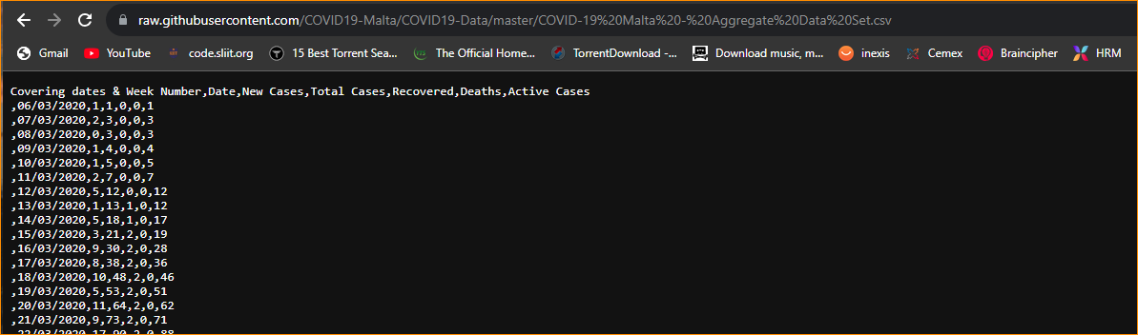

For that we have to use **Pandas** Package –

What is pandas pakage?

Pandas is a powerful tool for data manipulation and analysis in Python and is widely used in combination with other libraries like NumPy, Matplotlib, and scikit-learn for comprehensive data science workflows. Pandas is a powerful tool for data manipulation and analysis in Python and is widely used in combination with other libraries like NumPy, Matplotlib, and scikit-learn for comprehensive data science workflows.

Key features of the Pandas library include:

1. Data Structures:

DataFrame: A two-dimensional, tabular data structure with labeled axes (rows and columns). It is similar to a spreadsheet or SQL table.

Series: A one-dimensional labeled array that can hold any data type.

1. Data Cleaning and Preparation:

Pandas provides functions and methods for handling missing data, converting data types, reshaping datasets, and performing various data cleaning tasks.

1. Data Selection and Indexing:

Pandas allows for easy selection, indexing, and slicing of data. Users can access specific rows and columns using labels or integer-based indexing.

1. Data Filtering and Querying:

Users can filter and query data using conditional expressions, making it easy to extract subsets of data based on specific criteria.

1. Data Aggregation and Grouping:

Pandas supports grouping data based on specific criteria and performing aggregation operations (e.g., sum, mean, count) on grouped data.

1. Merging and Joining:

Pandas provides functionality for merging and joining datasets similar to SQL-style joins, allowing users to combine data from multiple sources.

1. Time Series and Date Functionality:

Pandas has built-in support for working with time series data and date-related operations, making it useful for analyzing temporal datasets.

1. Input/Output:

Pandas supports reading and writing data in various file formats, including CSV, Excel, SQL databases, and more.

Example –

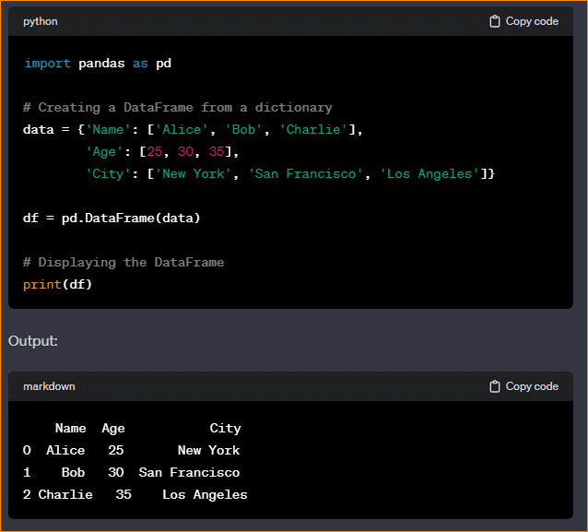

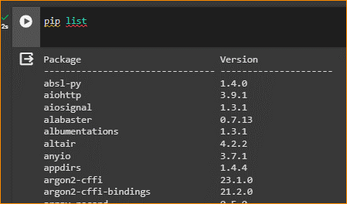

I has already installed-

